Week 15 Coding Assignment Solution

# Overview

This is one possible solution to the coding assignment. Do not look at this unless you are hopelessly stuck – or if you want to validate your solution.

# Classes in src/main/java

## pet.store.controller.PetStoreController.java

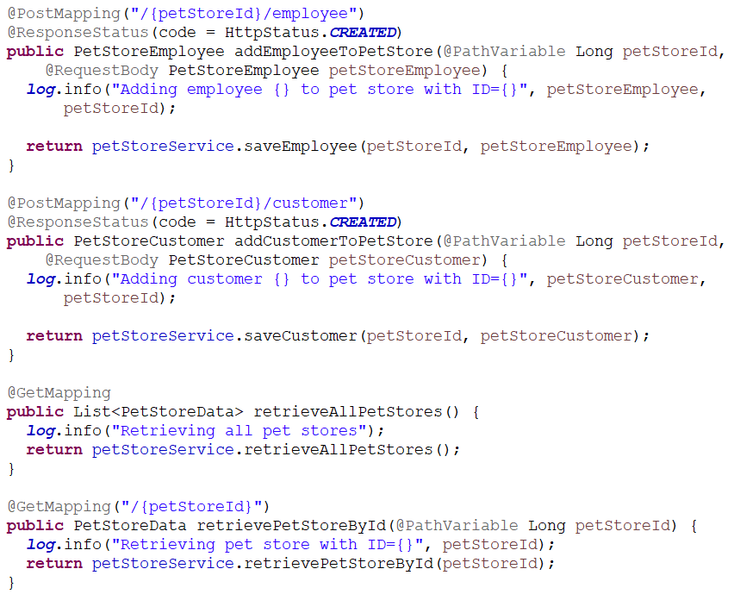

## pet.store.service.PetStoreService.java

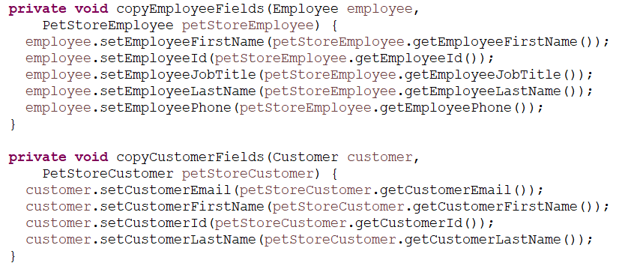

# Files in src/test/resources

## create-customer.json

## create-employee.json

